|  |
| --- |
| P2T  **C Programming under Linux** |
| Course Information Guide 2020-21 |
| An introduction to C Programming and the Linux Operating System |
|  |



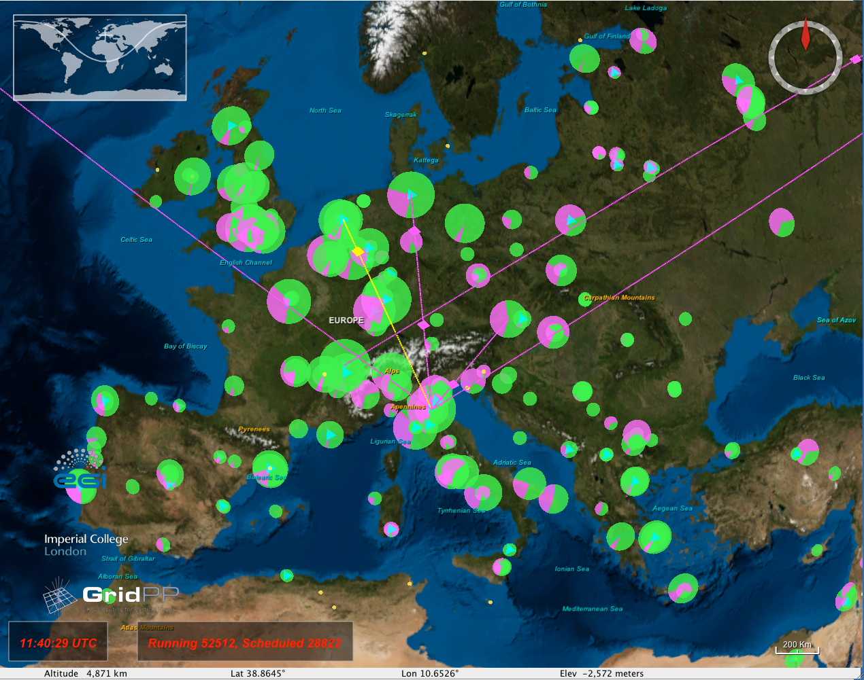

# Welcome statement from Head of School

*As the Head of School of Physics and Astronomy, I would like to welcome you to C Programming under Linux. The School prides itself in providing an excellent and supportive learning and teaching environment that is fully integrated with our research: in your lectures, laboratories and project work you will have the opportunity to interact with world-leading researchers working at the cutting edge of a wide range of fields of physics and astronomy, who are tackling some of the biggest contemporary challenges in science and technology.*

*All of our undergraduate degree programmes are accredited or recognised by the Institute of Physics and our teaching was highly commended in our most recent Periodic Subject Review by the Senate of the University. Our teaching has also attracted enthusiastic endorsement in recent years from our students in the National Student Survey and other surveys and barometers.*

*The School is firmly committed to supporting equally the careers and development of all its students and staff, as exemplified by our receipt of an Athena Swan Silver award for our support of women's careers. We value the diversity of our student body and recognise that this diversity improves the quality of our work by allowing students to bring a range of skills and viewpoints to inform and enhance their collective achievements. We therefore expect that all staff and students will work productively and professionally together in an atmosphere of mutual respect.*

*With this in mind, any reports of bullying, harassment, exclusion, or discriminatory behaviour will be taken very seriously by the School of Physics and Astronomy. If anyone wishes to report any untoward behaviour, speech or social media content from any person or group of people, they may do so in confidence to the Class Head or Lab Head, his/her Deputy, or to the School Equality and Diversity officers (currently Mrs Angela Eden and Prof Stephen McVitie), or to a trade union representative. All such concerns will be treated seriously and in confidence. (This includes incidents where students or staff are the targets or the perpetrators of such behaviour). Please at all times avoid potentially offensive "banter" with your fellow students, which may be hurtful and problematic for some, including those who witness it. Please note that claiming something was "banter" is in no way an excuse for bullying or harassing behaviour.*

*Although many of our classes are large in number, our teaching staff are friendly and approachable; if you have any questions about your course please don't hesitate to speak to them. They will do their very best to help.*

*I hope that you enjoy your time with us in the School of Physics and Astronomy and I wish you success with your current and future studies.*

*Best wishes*

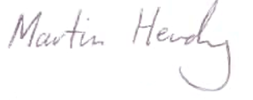

*Professor Martin Hendry*

*(Head of School)*

Contents

1 Welcome statement from Head of School 1

2 General Information and Introduction 3

3 Course Description 3

3.1 Intended Learning Outcomes 3

3.2 Content delivery 3

3.3 Assessment 4

3.4 Re-Assessment 4

3.5 Minimum requirements to avoid CR 4

3.6 Course Materials 4

3.7 How to get the best from your studies 4

4 Course Component Details 4

5 Adverse Circumstances 5

6 Getting help and advice 6

7 If things go wrong… 7

# General Information and Introduction

|  |  |
| --- | --- |
| **Fast Facts** |  |
| Course title | P2T: C Programming under Linux. |
| Course Credits | 10 Credits. |
| Semesters taught | Semester 2. |
| Essential Prerequisites | 40 credits at Level 1 with grade point average of at least 10. |
| Co-requisites | None. |
| Important dates: | Introduction lecture: Tuesday 12th January 2020 at 2pm. |
| Lectures | Tuesdays and Thursdays at 2pm. |
| Laboratories | Monday, or Wednesday, or Friday 2pm – 5pm. |
| Class test(s) | There is an optional Class Test scheduled on March 11th 2020. |
| Class Exam | There will be a **mandatory** 1-hour practical exam on March 23th 2020. There will be a 1-hour written exam paper in April/May. |
| Key Personnel:  Class head and C lecturer:  Linux lecturer:  Lab head:  Lab Demonstrators: | Prof. David Britton ([David.Britton AT glasgow.ac.uk](mailto:david.britton@glasgow.ac.uk))  Dr. Gareth Roy ([Gareth.Roy AT glasgow.ac.uk](mailto:gareth.roy@glasgow.ac.uk))  Dr. Sam Skipsey ([Samuel.Skipsey AT glasgow.ac.uk](mailto:Samuel.Skipsey@glasgow.ac.uk))  To be determined. |
| Moodle Site | http://moodle.gla.ac.uk/course/view.php?id=4314 |

# Course Description

The aims of the course are to introduce students to the Linux operating system and to the C programming language.

## Intended Learning Outcomes

The students should become competent users in a Linux environment that are able to carry out many routine tasks of working on a Linux PC. The students should attain the ability to write short programs in C, using standard structured programming techniques. The programs should be divided into separate functions and follow good programming practice. They also should be able to use typical Linux tools used for C programming under Linux.

## Content delivery

The course comprises of 20 lectures, including an introductory lecture, the class test and feedback session, which are complemented by 12 practical programming tasks (6 C and 6 Linux). Following guidance from the University it is currently planned to deliver all 2020-2021 lectures online via University approved methods. Details will be added to Moodle before lectures are given so it is essential that Students check updates on the Moodle site frequently.

We plan to run the practical lab-work on-line for the majority of students who have their own computer. However, the computing laboratory in **Room 320** of the Kelvin Building will be available for a limited number of students on Mon, Wed and Fri afternoons between 2pm and 5pm. It is essential that you only attend your assigned lab session on your set day, and we will need to set up some sort of booking system. Each student will be assigned a specific demonstrator and lab work will be submitted to your demonstrator via Moodle. Demonstrators will also be available online during given Lab hours.

## Assessment

Assessment consists of three components: 25% comes from the marking of laboratory work submitted to the demonstrators; 25% comes from the practical exam; and 50% from the written exam. All course work must be submitted on-time, as outline by the course calendar. Late submission will be assessed in accordance with the University policy that work will be assessed in the usual way, and the primary grade and secondary band so determined will then be reduced by two secondary bands for each working day (or part of a working day) the work was submitted late, any work that is submitted more than five days late being graded H.

## Re-Assessment

An opportunity for re-assessment will be provided only for the P2T written examination paper. For all other assessment components of P2T (lab work and practical exam) there will be no re-assessment opportunity available, due to the impracticality of such provision. This policy has been adopted with the approval of the Head of School and following the recommendation of the Physics and Astronomy Learning and Teaching Committee. Note: There is no re-sit of the practical exam and the minimum threshold (see below) must have been met.

## Minimum requirements to avoid CR

A minimum of 50% of the C and 50% of the Linux laboratory projects must be submitted. The practical exam and written exam must be taken.

## Course Materials

No specific textbooks are recommended. The use of online resources is part of the course and provides excellent and readily available help.

## How to get the best from your studies

The **only** way to learn how to program is to try it out! You are strongly encouraged to engage early and fully with the practical work in the laboratories. Some students use laptops during or after the lecture to try coding snippets of code as the lecturer demonstrates examples.

# Course Component Details

## Linux:

Introduction: Linux, the kernel and multi-user environments

The Command Line

- Files, Processes and the Shell

- Finding help (**man**,...)

Navigating the filesystem

- Navigation basics (**cd**, **ls**,...)

- Searching and Finding (**find**, **locate**,...)

Working with files

- File tools (**cat**, **grep**, **tail**, **head**...)

- Permissions

Working with processes

- Operating System Commands (**top**,**ps**,...)

- Stdin & Stdout

- Pipes and Redirection

Shell Scripting

- Shell Variables

- Control flow

Building Software

- The Gnu Compiler Collection

- Gnu Make

- Revision Control

## C Programming

The main() function

#include and #define directives

Variable types

Operators and expressions

Control flow (do...while, for, if..else, switch,...)

Function calls

Pointers and arrays

Input and Output

Libraries

Good programming practice

# Adverse Circumstances

Students are expected to attend all lectures and communicate with their lab demonstrators once a week during the lab sessions. If you miss an examination or an assessment deadline, or if you believe your assessment performance has been affected by adverse circumstances, you should submit a **Good Cause Claim**, and this must be via MyCampus.

Submission of a Good Cause Claim is the mechanism that allows your circumstances to be considered by the Board of Examiners. Please note all Good Cause Claims must be submitted within **one week** of the date of the affected assessment.

Students should note that the University’s Code of Assessment allows grades to be awarded only on the basis of demonstrated work. So, if you feel that some piece of assessed work has been affected by adverse circumstances, and if staff agree, then the only course of action available is for the grade for that piece of work to be set aside (in the case of continuously assessed work and Class Tests) or to allow a resit (in the case of Degree Exams) – marks cannot be adjusted.

To submit a Good Cause Claim on MyCampus:

1.    Go to the ‘Student Centre’ and select *My Good Cause* from the Academics menu.

2.    Select the relevant course(s).

3.    Complete the report in MyCampus (there is provision for particularly sensitive information to be provided separately, outwith the system, but a claim report must still be entered into MyCampus).

4.    Add supporting evidence by uploading documents. (Scanners are available on level 3 of the University Library.) It is the responsibility of the student to keep all original documentation and submit it to the Class Head on request.

If you encounter any difficulties with this process please contact the Class Head immediately to let him or her know you have a problem with your Good Cause Claim.

What will happen to your Good Cause Claim

The Course Administrator and/or Class Head will ensure that your claim is considered, and this will be in accordance with the section of the Code of Assessment which covers incomplete assessment and good cause (paragraphs 16.45 to 16.53). The outcome of your claim will be posted into the Approval Information section on your Good Cause Claim in MyCampus. If it is accepted that your assessment was affected by good cause, the work in question will be set aside and you will (as far as is practicable) be given another opportunity to take the assessment with the affected attempt discounted.

For absences that are significant but for which a good cause claim is not being filed, students must complete a **MyCampus absence report**. A significant absence is defined to be:

* an absence of **more than seven consecutive days** during working periods
* an absence of **any duration** if it prevents a student from for example fulfilling any minimum requirement for the award of credit (e.g. missing attendance at one day of a two-day laboratory, but where the work was nonetheless submitted and therefore not involving a Good Cause claim).

All potentially significant absences should be reported as soon as is practical, by completing part 1 of the MyCampus absence report. Part 2 of the MyCampus absence report should be completed on return to university. The normal submission deadline for the completed absence report is 7 days after return to university. Documentary evidence is required when reporting any significant absence.

See also the Senate Office Absence Policy: <http://www.gla.ac.uk/services/senateoffice/policies/studentsupport/absencepolicy/>

# Getting help and advice

Your adviser of studies, Class and Lab Heads, lecturers and demonstrators are all here to help you and you should feel free to approach them for help and advice during the year. Particularly if you are getting into difficulties, it is very important that you talk to someone at an early stage. The university also provides counseling services and study advice, and you can find information about that on the web:

http://www.gla.ac.uk/students/support

# If things go wrong…

We hope you will be happy in your studies here but if things are not going well, then please raise issues of any kind that are affecting your studies. Talk to teaching staff or your adviser, as early as you can so that we can help.

The University is committed to providing an excellent experience for our students. However, if you are in the situation of having a complaint, then the University has a Complaints Procedure in line with the Scottish Public Services Ombudsman requirements. If you have a formal complaint then in the first instance please raise it with a member of staff in the area concerned. We aim to provide a response to the complaint within five working days. This is Stage 1.

If you are not satisfied with the response provided at Stage 1 you may take the complaint to Stage 2 of the procedure. Similarly, if your complaint is complex, you may choose to go straight to Stage 2. At this stage the University will undertake a detailed investigation of the complaint, aiming to provide a final response within 20 working days.

You can raise a Stage 2 complaint in the following ways: by e-mail: complaints@glasgow.ac.uk; by phone: 0141 330 2506; by post: The Senate Office, The University of Glasgow, Glasgow, G12 8QQ; by person: The Senate Office, Gilbert Scott Building, The University of Glasgow.

Complaints do not have to be made in writing but you are encouraged to submit the completed Complaint Form (available at:

http://www.gla.ac.uk/services/senateoffice/studentcodes/students/complaints/ ) whether it is at Stage 1 or Stage 2. This will help to clarify the nature of the complaint and the remedy that you are seeking.

Remember that the SRC Advice Centre (Students Representative Council) is available to provide advice and assistance if you are considering making a complaint. (Tel: 0141 339 8541; e-mail: advice@src.gla.ac.uk)